Any questions: alexandra@youarenotyourbehaviour.com
Booking Form

Please reserve me a place on the course below:
MOM Training with Andrew T. Austin

Edinburgh Training and Conference Venue, EH1 1SU 12th-17th October 2019

Name

Dates Attending

Payment Amount

Address

Telephone |  | Mobile
Email:

Signed________________________________________ Date____________________

To secure your place, please book by paying through the PayPal links on the left of my event page (accepts PayPal and Credit or Debit cards) or ask me for a banking invoice or instalments. For more information see “Booking & Payment”: http://www.youarenotyourbehaviour.com/resources/mom-scotland-2019/

Accommodation:
Edinburgh has every type of accommodation you can imagine, but booking in advance is advised. Some discounted accommodation is also available through the venue - Edinburgh Training and Conference Venue: https://www.edintrain.com/find-accommodation/
http://www.visitscotland.com/destinations-maps/edinburgh-lothians/accommodation/

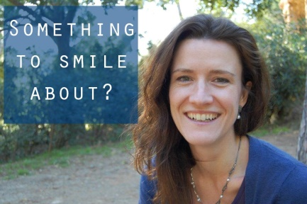

Cancellation Policy
Up to 2 calendar months before event: full refund
Up to 4 weeks before event: refund minus £100 fee
After that 50% refund only
Alternatively, another person can take you place by arrangement

Email: alexandra@youarenotyourbehaviour.com

Website: http://www.youarenotyourbehaviour.com/resources/
Join the event on Facebook: https://www.facebook.com/events/546485152529544/

