Any questions: alexandra@youarenotyourbehaviour.com
Booking Form

Please reserve me a place on the course below:
OldPain2Go Practitioner Training in Edinburgh with Alan Johnson

Edinburgh Training and Conference Venue, EH1 1SU 30th November 2019

Name

Payment Amount

Address

Telephone |  | Mobile
Email:

Signed________________________________________ Date____________________

To secure your place, please book by paying through the Paypal link on the left of my event page (accepts Paypal and Credit or Debit cards): https://www.youarenotyourbehaviour.com/resources/oldpain2go-practitioner-training-scotland/

Accommodation:
Edinburgh has every type of accommodation you can imagine, but booking in advance is advised. Discounted accommodation is also available through the venue - Edinburgh Training and Conference Venue: https://www.edintrain.com/find-accommodation/
http://www.visitscotland.com/destinations-maps/edinburgh-lothians/accommodation/

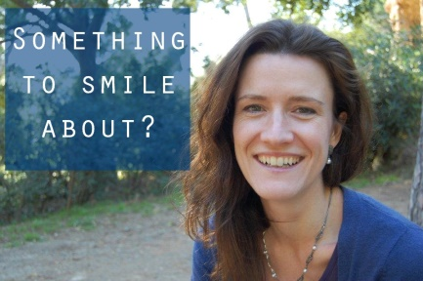

Cancellation Policy
Up to 2 calendar months before event: full refund
Up to 1 calendar month before event: refund minus £100 fee
After 15thNovember: £50 refund only
Alternatively, another person can take you place by arrangement

Email: alexandra@youarenotyourbehaviour.com

Website: http://www.youarenotyourbehaviour.com/resources/
Join the event on Facebook: https://www.facebook.com/events/1092317174287330/

